AN AI-DRIVEN BIG DATA SENTIMENT ANALYTICS FRAMEWORK FOR CYBER-SOCIAL INTELLIGENCE USING LARGE-SCALE SOCIAL MEDIA DATA
Asro Harun¹*, Abdul Rozi², Chairuddin³
¹ Politeknik PGRI Banten | ² IKMINDO | ³ Indonesia Mandiri
*Corresponding Author: asro@politeknikpgribanten.ac.id
Received: March 2026 | Accepted: May 2026 | Published: June 2026 | DOI: xx.xxxx/asrosaintek

Abstract
This study proposes an AI-driven framework for sentiment analytics using large-scale social media data. The framework integrates TF-IDF, machine learning, and visualization to support cyber-social intelligence.

Keywords
Artificial Intelligence; Big Data; Sentiment Analysis; Machine Learning; Data Mining

Introduction
Write background, problem statement, research gap, novelty, objectives, and contributions. Example: Social media produces large-scale opinion data requiring intelligent analysis.

Literature Review
Review AI, Machine Learning, Sentiment Analysis, Big Data, and previous studies. Explain research gap and theoretical framework.

Research Method
Describe data collection, preprocessing, feature extraction, classification, and evaluation metrics.

Results and Discussion
Present tables, graphs, confusion matrix, and detailed interpretation of findings.

Conclusion
Summarize findings, contributions, limitations, and future work.

Acknowledgement
Thank institutions, funding agencies, and contributors.
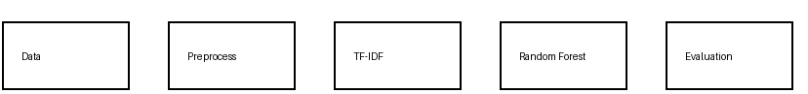

Figure 1. Research Flowchart
Description of the flowchart bellow

Table 1. Performance Results
Method | Accuracy | Precision | Recall | F1
NB | 85% | 84% | 83% | 83%
SVM | 90% | 89% | 89% | 89%
RF | 93% | 92% | 92% | 92%

Description of the table bellow
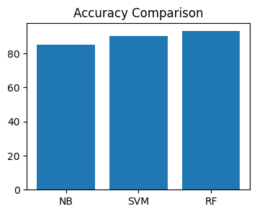

Figure 2. Accuracy Comparison

Description of the graphic table on top bellow

Example Discussion
Random Forest achieved the highest accuracy (93%). This indicates ensemble methods can better handle noisy social media data. The result is consistent with previous studies and supports the effectiveness of machine learning for sentiment classification.

References (15 Examples)
Using APA Style 7th edition.

